**FOUR STAGE AND OPERATION**  
**EXP NO: 38**  
**AIM:**To write a C program to implement four stage and operation.  
**PROCEDURE:**

1. Initialize `counter` to 1.

2. Input `a` (NUMBER-1) and increment `counter`.

3. Input `b` (NUMBER-2) and increment `counter`.

4. Display the menu for the user to choose an operation.

5. Based on the user's choice, perform the corresponding operation and update `res`.

6. Print the result and increment `counter`.

7. Print the cycle value.

8. Input the number of instructions (`ins`).

9. Calculate the performance measure as `(float)ins / counter`.

10. Print the performance measure.

**PROGRAM:**

#include <stdio.h>

int main() {

int counter = 1;

int a, b, choice, res;

// Input for NUMBER-1

printf("ENTER NUMBER-1-");

scanf("%d", &a);

counter += 1;

// Input for NUMBER-2

printf("ENTER NUMBER-2-");

scanf("%d", &b);

counter += 1;

// User choice for operation

printf("1-ADDITION 2-SUBTRACTION 3-MULTIPLICATION 4-DIVISION\n");

printf("Enter Your Choice\n");

scanf("%d", &choice);

// Perform the selected operation

if (choice == 1) {

printf("Performing Addition...\n");

res = a + b;

counter += 1;

} else if (choice == 2) {

printf("Performing Subtraction...\n");

res = a - b;

counter += 1;

} else if (choice == 3) {

printf("Performing Multiplication\n");

res = a * b;

counter += 1;

} else if (choice == 4) {

if (b == 0) {

printf("Denominator can't be Zero\n");

} else {

printf("Performing Division...\n");

res = a / b;

counter += 1;

}

} else {

printf("Enter Correct Input\n");

}

// Print the result

printf("%d\n", res);

counter += 3;

// Print the cycle value

printf("CYCLE VALUE IS: %d\n", counter);

// Input for the number of instructions

int ins;

printf("Enter the No. of instructions:");

scanf("%d", &ins);

float performance_measure = (float)ins / counter;

// Print the performance measure

printf("performance measure is: %f\n", performance_measure);

return 0;

}

**Input:**

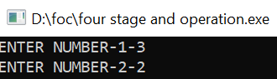

**OUTPUT:**

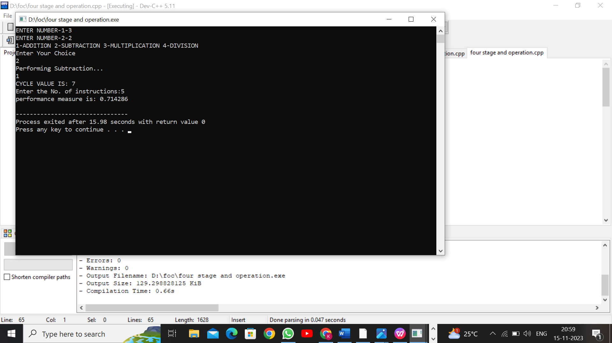

   
**RESULT:**Thus  
the program was executed successfully using DevC++.